Nepal College of information Technology
Imadol lalitpur
Unit Test Fall Semester 2006/2007

Program : B.E Semester: I
Time : 2hrs Year : I

FM 60 PM :30

Engineering Math-III

1 a) In which condition inverse of a matrix exists? Find the Inverse of A=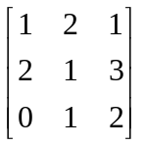 1+7
b) Show that 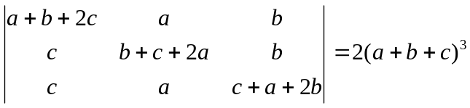 7
2 a) Solve the equation by Gauss elimination method. 8
x + y +2z = 4
3x - 4y + 2z = 1
2x - 3y -7z = -8
b) Define linearly dependent and independent set of vectors. Check linearly dependent or independent set of vectors 2+5
u₁ = ( 2, 1, 1) u₂ = (3, -2, 2), u₃ = (-1, 2, -1)
3. a) Define rank of matrix. Find the rank of the matrix.
A= 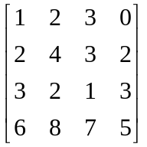
b) Define linear transformation. Check the following transformation is linear or not.
T : R²→R² defined by T (x,y) = (x + y, 0) 7
4. a) Find the eigen value and eigen vector of A=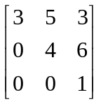 8
b) Define periodic function. Find the period of f (x) = cos (2πx) 3
c) Define even and odd function. Check the function is even, odd or neither. f(x)= 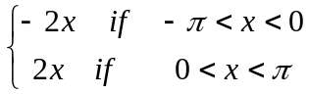 4
5. Attempt any two 2.5*2
i) Solve by crammer's rule:
x + 2y = 3
3x + 4y =7
ii) Prove 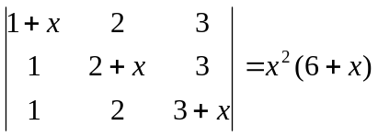
iii) Define symmetric and skew symmetric matrix with examples.

